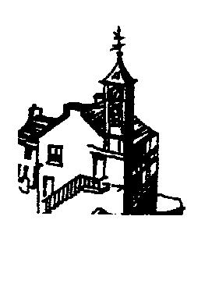
Annual Parish Meeting Maker with Rame Parish
Thursday 11th May 2017 at 6.00 pm
The Institute, Kingsand

AGENDA
Items for inclusion at the meeting should be lodged with the
Clerk to the Parish Council before the meeting

- Apologies for absence
- To approve minutes of Annual Parish Meeting 12th May 2016
- Chairman’s Report
- Financial Report
- Police Report
- Any other organisation reports
Rame Peninsula Beach Care
Community Hall
Institute
Rame Tourism and Business Association
Rame Gig Club
Rame Peninsula Trust
Sailing Club
Youth Club
Chat

Parish Council
Chairman Rebecca Lingard

